Ultimate Guide to College Supplemental Essays
Bonus Material: 50+ Supplemental Essays That Worked
If you’re applying to 5, 8, or 12 or more colleges, you’re probably looking at a pretty big pile of supplemental essays to write.
But don’t panic – you can save yourself a ton of time and effort by slotting all these essays into just a few categories.
In this post, we’ll go through the common types of supplemental essays and how to approach them, plus dos and don’ts for any supplemental essay prompt.
And to see what colleges are really looking for, take a look at our collection of 50+ real essays that worked for students applying to Ivy+ schools.
Download 50+ Supplemental Essays That Worked
Jump to section:
3 Steps to Tackle Your Supplemental Essays
The “Why Us” Essay
The Academic/“Why This Major” Essay
The Community Essay
The Extracurricular Essay
The Identity Essay
Other Essay Types
Supplemental Essay Guides for Specific Colleges
Supplement essay dos and don’ts
Next Steps

3 Steps to Tackle Your Supplemental Essays
Instead of diving headfirst into writing your supplement essays, start by figuring out how much you actually need to write – and how much time you can save.
Here’s how:
- Make a list of all the essay prompts you need to write.
- Categorize each essay prompt: is it a “why us,” “why this major,” community, extracurricular, or identity essay? Or is it a creative essay that falls outside those categories?
- Now, write an essay for each of those prompts and tweak it to fit the specific prompt for each college.
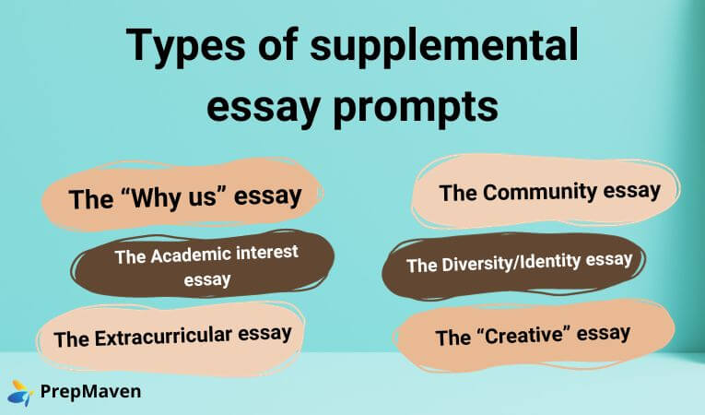
So how do you write a stand-out essay in each of those categories? Below, we’ll go through how to approach each common type of supplemental essay.
And to get inspired by real essays that got their writers into great schools, grab our free download at the link below.
Download 50+ Supplemental Essays That Worked

The “Why Us” essay
Why do colleges care why you’ve chosen to apply there?
Especially at more competitive colleges, admissions officers might see many applications from students who applied to a ton of highly selective schools. Maybe they’re hedging their bets since admission rates are so low.
Or maybe they just want to go to a highly prestigious school, and they don’t really care which one. (An admissions officer at Brown told me that in the Regular Decision round, “I see a lot of applicants who think that Brown is spelled Y-A-L-E.” Don’t forget to proofread your applications before hitting submit!)
The “Why Us” essay not only assesses your writing skills and core values but also tries to see if you’re genuinely interested in the school – and if you’re likely to enroll if you get in.
Colleges often ask the “Why us?” question in one of three ways:
- An overall question asking you to focus on anything that appeals to you about the school.
- A specific question asking how you’ll use the school’s resources to pursue your academic interests.
- A specific question asking how you’ll engage with non-academic elements of the school, often framed around community.

We’ve written a detailed post that breaks down everything you need to do to answer the “Why us?” prompt – check that out when you’re ready to start drafting.
But, in a nutshell, here’s what a prompt like this is asking for:
- Specific elements of the school’s curriculum, programs, or culture that appeal to you.
- How your values and experiences make you a good fit for those specific aspects of the school.
Basically, you want to highlight what you like about the school and then link that back to your own story. The second part is what a lot of students forget.
But this isn’t an essay about why the school is great – it’s about why you want to go there.
Obviously, you can’t copy-paste this essay for each school on your list. But you can streamline the writing process by writing a basic template for this essay and then tailoring the first part to each college.
What not to do for this essay prompt is to go on the college’s website and start dumping in irrelevant information about the school. Namedropping a professor whose class you want to take or a dorm you’d love to live in can come across as inauthentic.
Instead, talk about the school’s strengths and why those are a good fit for your own interests and goals.
Contact Us for 1-1 Essay Support

The Academic/“Why this Major” essay
Don’t be fooled: these common essay types are two sides of the same coin.
You don’t need to write separate essay templates for prompts that ask about your “academic interest” and those about your intended major. Both of these prompts are asking for the same thing:
- Explain what you’re interested in specifically.
- Show, with details from your life, why it interests you.
- Address how you’ll engage the specific resources of the college you’re applying to.

Try to start this essay with an interesting “hook.” “I want to study Global Health” is not a very interesting hook. But “My palms are shaking to the point where I contemplate abandoning the mission” will get your reader interested. (This is the start of a real essay that got its writer into Cornell – download our collection of 50+ real supplemental essays to read the rest!)
Download 50+ Supplemental Essays That Worked
Once you have your reader’s attention, go into the “why.” What intrigues you about this field? This is also the place to talk about any experience you have doing research or learning about your area of interest.
Finally, if the word count gives you space, connect this to the school’s specific offerings.
Again, instead of dropping in professors’ names or course titles at random, try to go deeper: does the school have a freshman science intensive or interdisciplinary humanities program? How will this college specifically help you explore your academic interests?
What if you’re undecided? That’s fine – but you should still talk about what interests you and why.
One big don’t for this essay type: do not say that you’re choosing your major so you can make money. Of course, career prospects might be a factor in your choice…but here, you want to emphasize your intellectual interest, not the average salary on graduation.
To get more specific on how to write the “why this major” essay, check out our dedicated post on this essay type.

The Community Essay
This is another important way that schools can differentiate between highly qualified applicants. They want to see that you’ll make a positive contribution to the community.

This is not the place to tell the admissions committee all about the vibrant musical theater community on campus. They already know that!
Instead:
- Show how you’ve been an engaged member of a specific community.
- Explain what you did and learned as part of that community.
- Talk about how you’ll be an active member of the community to which you’re applying, including by referencing specific offerings/programs/organizations at that university (but without throwing the whole Student Life page of their website back at them).
Rather than just stating that you’re part of a community, get specific about what you have done within your community and what community means to you. What impact have you had? How has it shaped how you’ll take part in communities on campus and throughout your life?
Think beyond formal communities. It’s fine to talk about your sports team or religious community, but you’re also free to write about, say, the community you’ve formed with older folks at the home where you volunteer.
Contact Us for 1-1 Essay Support

The Extracurricular Essay
You don’t have to be winning robotics competitions or training for the Olympics to write a great extracurricular essay.
As we outline in our longer post all about this essay type, this is the gold standard structure that you want to follow for essays on extracurriculars:
- Start with a story
- Give an overview
- Show your passion
- Reflect on how the activity has shaped you

This is not a resume – so don’t just list your accomplishments, as tempting as that can be.
Instead, show how a particular activity has shaped you. You want to show development – not just that you got better at dancing or won prizes for your poetry, but that you’re a well-rounded person who cares about something other than their SAT score.
Download 50+ Supplemental Essays That Worked

The Identity Essay
The final common supplemental essay type is about identity or diversity. The way this prompt is phrased can vary, but it comes down to the same thing: who are you, and what does that mean to you?
Some students have a background that they feel is important to share in their application, whether ethnic, religious, LGBTQ+, or anything else. If so, this is a good place to do that.

But if you don’t want to talk about any specific aspect of your identity, you can still write a great response to this prompt.
- Interpret this prompt broadly, making it fit your understanding of “identity” or “diversity.”
- Use real moments from your life in your response to this prompt.
- Connect your identity to your views on community, social issues, or education more broadly.
This is a personal essay, not an opinion column, so you should use examples from your life – but don’t limit yourself to your own experience. Explain how that personal experience has shaped your academic interests, career goals, or outlook on life. (It’s best to steer clear of especially inflammatory or controversial topics, but you don’t need to avoid politics entirely, either.)
Like all college essays, this is a chance for you to show something important about yourself and what you’ve done.

Your identity might be that of a first-generation American who started a language club at her church to help kids in the community keep up with their parents’ language.
Or your identity might be that of a big brother who learned the importance of that label when caring for a disabled younger sibling, and now you want to improve education access for kids with disabilities.
Think broad, and don’t forget to share why your identity is meaningful to you!
And, if you need someone to guide you through the process of writing this kind of essay, there’s nobody better than one of our college essay experts, who have all successfully navigated the college application process themselves.

Other Essay Types
Though many supplemental essays fall into one of these categories, some colleges like to ask creative or nontraditional questions too.
The University of Chicago is famous for this. Here’s one of their essay prompts from this year:
“Left” can mean remaining or departed. “Dust” can mean to add fine particles or to remove them. “Fast” can mean moving quickly or fixed firmly in place. These contronyms—words that are their own antonyms—somehow hold opposing meanings in perfect tension. Explore a contronym: a role, identity, or experience in your life that has contained its own opposite.
Other colleges ask questions with super-short word counts, like giving you 20 words to name someone who inspires you.
The best way to excel on these essays is to work with a qualified college essay coach who’s been through the process. But either way, the key to these questions is to remember that they’re an opportunity to show something about yourself as an applicant.
Talking about someone who inspires you? Don’t just list their name and a fact about them – mention why they inspire you and what they’ve inspired you to do.
Contact Us for 1-1 Essay Support

Supplemental Essay Guides for Specific Colleges
Generally, the supplemental essay prompts you’ll see will probably fall into one of these categories.

We’ve lined up advice on specific colleges and universities in this series of posts. If you’re applying to any of these schools, check out the detailed guidance on approaching their supplemental essays:
- Brown University
  - Prompt types: academic interests, community, & extracurriculars
- Columbia University
  - Prompt types: community, “why us,” “why this major”
- Dartmouth College
  - Prompt types: “why us”
- Harvard University
  - Prompt types: diversity/community, extracurriculars
- Princeton University
  - Prompt types: “why this major,” diversity/community
- University of Pennsylvania
  - Prompt types: community, “why us”/”why this major,”
- Yale University
  - Prompt types: “why this major,” “why us,” community

Supplement Essay Dos and Don’ts
Don’t:
- Make sweeping generalizations about the strength of the program, the prestige of the faculty, or the rigor of the academics.
- Focus too much on the location of the school, especially for schools in major cities like NYC.
- Name-drop professors or classes at random (anyone can Google the school’s course catalog!). If you’ve worked with a professor during a summer program or internship, feel free to mention that – but there should be a meaningful connection.
- Skip “optional” essays. Always write a response when a school provides a prompt.
Do:
- Focus on specifics about the school and its programs.
- Tie everything you say about the school back to your own experiences, interests, and goals.
- Make sure every sentence is specific. If you spot a sentence that could have been written by someone else (like “I am passionate about XYZ”), it’s time to edit.

Next Steps
If you’re ready to get drafting, get in touch for a free consultation on college essay coaching. Our essay coaches have helped hundreds of students get into their goal schools, and they’ve all navigated the process themselves, too.
And in the meantime, check out real supplemental essays that worked to get a sense of what colleges are looking for.

